# Solution

In the screenshot below that the user sent, the list of roles is empty because the user did not define the roles and allow them to be assignable in the course categories.

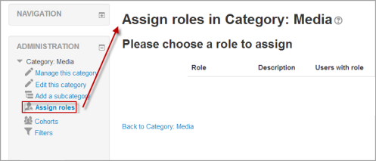

The user is requesting to be able to do so from the same screen and therefore, a link to the “Permissions” will be added in the administration block as follows:

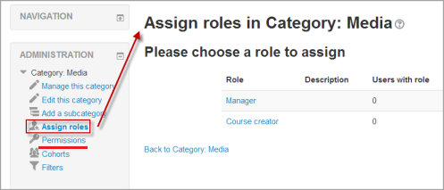

By clicking this permissions link will open to the feature “Assigning Roles > Context and roles” in the roles and permissions module, which as explained in the feature will open the context types where this role is allowed to be assigned:

